## **Game Screen Elements Subsystem**

As the name of the subsystem designates this system holds objects of the game. There are several objects for our game including player, enemies, power-up and other objects which all inherits from main object class myObjects.

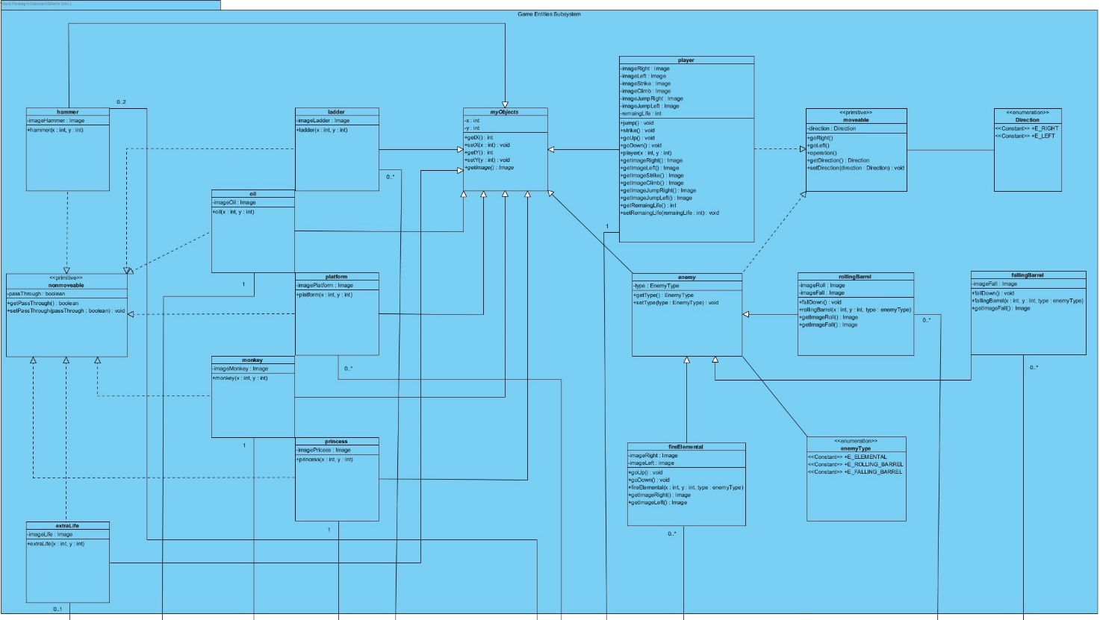

Figure # - Diagram of GameScreenElements

**myObject Class**

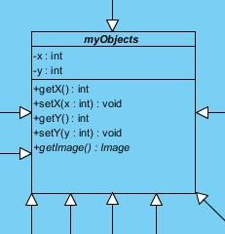

“myObject” class will be parent class of objects in the game, additionally this class will be instantiated when player starts the game. Also, “myObject” class have main operation including getting, setting position of another object and getting image of the needed object. Positions of the characters will be kept in the entities of these class.

**Player Class**

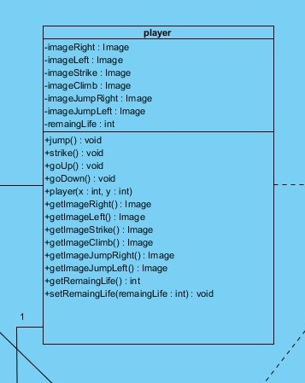

The “Player” class have some special operation and attributes including images of different states of the player, and special operations to use this images. Additionally, in this class operations like jump(), strike(), goUp(), goDown() which these operations are very important in player moves. Also, there are entities for keeping number of lives of player which these entites can be set and get by specific operations.

**Enemy Class**

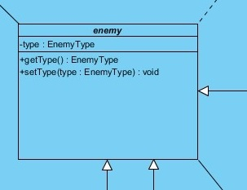

Another important class is “enemy” class which all other enemy type classes inherits from this class. This class decides the type of the enemy like rollingBarrel, fallingBarrel, and fireElemental. These diagram demonstrates their relation with enemy class.

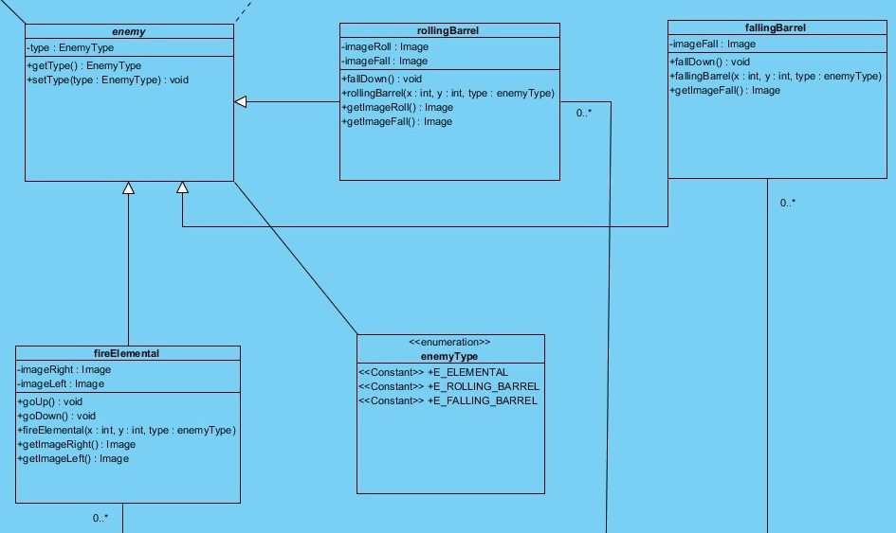

Every other class which inherits to the “enemy” class are rollingBarrel, fallingBarrel, and fireElemental, which all have different images for different states of the objects and consturctors that keep their positions and Enumeration type.

On the other hand, there are “nonmovable” objects like ladder, oil, platform, hammer, monkey, princess, extraLife which these objects will only keep images and constructors